CS 499 Module One Assignment Template
By: Chris Trimble

Complete this template by replacing the bracketed text with the relevant information.

- Self-Introduction: Address all of the following questions to introduce yourself.

  - How long have you been in the Computer Science program?

I have been in the Computer Science program here at SNHU for about a year and a half. Throughout the program, I have progressed from foundational programming concepts to advanced coursework in software engineering, data structures, databases, mobile development and cybersecurity.

  - What have you learned while in the program? List three of the most important concepts or skills you have learned.

Software Engineering and Design: Design modular, maintainable applications using object-oriented principles and SDLC methodologies.

Algorithms and Data Structures: Applying algorithmic thinking, efficiency analysis and appropriate data structures to solve problems.

Secure Coding and Cybersecurity: Identifying vulnerabilities, implementing mitigations and developing a security-first mindset.

  - Discuss the specific skills you aim to demonstrate through your enhancements to reach each of the course outcomes.

Through my enhancements, I aim to demonstrate advanced problem solving, clean software design, algorithm optimization, secure coding practices, and professional documentation skills. These enhancements will highlight my ability to improve existing systems while adhering to industry standards.

  - How do the specific skills you will demonstrate align with your career plans related to your degree?

These skills directly align with my career goal of working in cybersecurity and secure software development, where secure architecture, risk mitigation, and system optimization are critical.

  - How does this contribute to the specialization you are targeting for your career?

The enhancements support my cybersecurity specialization by demonstrating secure coding, vulnerability awareness and defensive design practices.

- ePortfolio Set Up:

  - Submit a screen capture of your ePortfolio GitHub Pages home page that clearly shows your URL.
    - You already have a repository in GitHub where you uploaded projects in previous courses. Your ePortfolio will reside in GitHub but can link to work at other sites, such as Bitbucket.

  - Use the GitHub Pages link in the Resource section for directions on:
    - How to create your GitHub website and publish code to GitHub Pages
    - Issues, such as adding links to other sites

  - Paste a screenshot of your GitHub Pages home page with your URL clearly showing in the space below.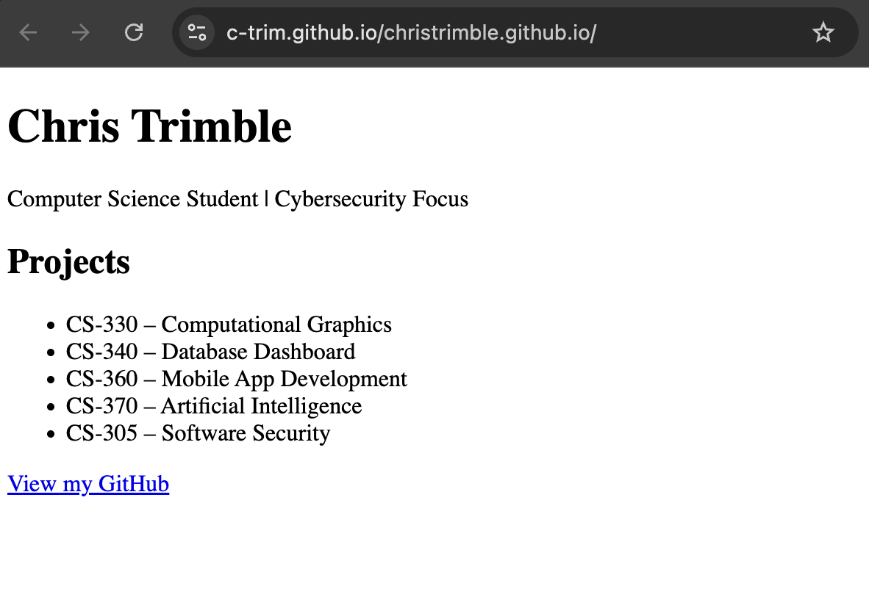

- Enhancement Plan:

  - Category One: Software Engineering and Design
    - Select an artifact that is aligned with the software engineering and design category and explain its origin. Submit a file containing the code for the artifact you choose with your enhancement plan.

The selected artifact is CS 320 Project Two: The Task, Appointment and Contact Service application written in Java. This artifact was developed as part of the Software Testing, Automation and Quality Assurance course and demonstrates object-oriented design, input validation and unit testing.

Note: Your artifact may be work from the following courses:

- IT 145: Foundation in Application Development
- CS 250: Software Development Lifecycle
- CS 260: Data Structures and Algorithms
- IT 315: Object Oriented Analysis and Design
- CS 320: Software Testing, Automation, and Quality Assurance
- CS 330: Computational Graphics and Visualization
- CS 340: Advanced Programming Concepts
- CS 350: Emerging Systems Architectures and Technologies
- CS 360: Mobile Architecture and Programming
- IT 365: Operating Environments
- IT 380: Cybersecurity and Information Assurance
- CS 405: Secure Coding
- CS 410: Reverse Software engineering
- IT 340: Network and Telecommunication Management
- IT 380: Cybersecurity and Information Assurance

    - Describe a practical, well-illustrated plan for enhancement in alignment with the category, including a pseudocode or flowchart that illustrates the planned enhancement.

The enhancement will focus on improving software architecture and maintainability. Planned improvements include introducing service interfaces, refactoring validation logic into reusable validator classes, improving exception handling and enhancing documentation to reflect professional software engineering standards.

Pseudocode:

START
Receive request
Validate input using Validator interface
IF validation fails
Throw descriptive exception
ELSE
Process request in Service implementation
Return result
END

For this category of enhancement, consider improving a piece of software, transferring a project into a different language, reverse engineering a piece of software for a different operating system, or expanding a project’s complexity. These are just recommendations. Consider being creative and proposing an alternative enhancement to your instructor.

Think about what additions to include to complete the enhancement criteria in this category. Since one example option is to port to a new language, that is the kind of scale that is expected. This does not mean you need to port to a new language but instead have an equivalent scale of enhancement. Underlying expectations of any enhancement include fixing errors, debugging, and cleaning up comments, but these are not enhancements themselves.

    - Explain how the planned enhancement will demonstrate specific skills and align with course outcomes.

      - Identify and describe the specific skills you will demonstrate that align with the course outcome.

Skills Demonstrated:
Modular software design
Refactoring and maintainability
Professional documentation

      - Select one or more of the course outcomes below that your enhancement will align with.

Course Outcomes Aligned:
Outcome 2
Outcome 3
Outcome 4
Course Outcomes:

- Employ strategies for building collaborative environments that enable diverse audiences to support organizational decision-making in the field of computer science.
- Design, develop, and deliver professional-quality oral, written, and visual communications that are coherent, technically sound, and appropriately adapted to specific audiences and contexts.
- Design and evaluate computing solutions that solve a given problem using algorithmic principles and computer science practices and standards appropriate to its solution while managing the trade-offs involved in design choices.
- Demonstrate an ability to use well-founded and innovative techniques, skills, and tools in computing practices for the purpose of implementing computer solutions that deliver value and accomplish industry-specific goals.
- Develop a security mindset that anticipates adversarial exploits in software architecture and designs to expose potential vulnerabilities, mitigate design flaws, and ensure privacy and enhanced security of data and resources.

  - Category Two: Algorithms and Data Structures

- Select an artifact that is aligned with the algorithms and data structures category and explain its origin. Submit a file containing the code for the artifact you choose with your enhancement plan. You may choose work from the courses listed under Category One.

The same CS 320 Project Two artifact will be used, focusing specifically on its internal use of data structures such as lists and hash maps to manage tasks, appointments and contacts.

- Describe a practical, well-illustrated plan for enhancement in alignment with the category, including a pseudocode or flowchart that illustrates the planned enhancement.

The enhancement will focus on improving algorithm efficiency by replacing list-based searches with hash-based data structures such as HashMap. This change reduces lookup operations from O(n) time complexity to O(1), improving performance and scalability as the data set grows.

Pseudocode:

START

Store objects in HashMap<ID, Object>

Retrieve objects using key in O(1) time

END

For this category of enhancement, consider improving the efficiency of a project or expanding the complexity of the use of data structures and algorithms for your artifact. These are just recommendations. Consider being creative and proposing an alternative enhancement to your instructor. Note: You only need to choose one type of enhancement per category.

Think about what additions to include to complete the enhancement criteria in this category. Since one example option is to port to a new language, that is the kind of scale that is expected. Perhaps you might increase the efficiency and time complexity of an algorithm in an application and detail the logic of the increased time complexity. Remember, you do not need to port to a new language but instead have an equivalent scale of enhancement. Underlying expectations of any enhancement include fixing errors, debugging, and cleaning up comments, but these are not enhancements themselves.

- Explain how the planned enhancement will demonstrate specific skills and align with course outcomes.

  - Identify and describe the specific skills you will demonstrate to align with the course outcome.

Skills Demonstrated:
Algorithm efficiency analysis
Time complexity evaluation using Big-O notation
Appropriate data structure selection

  - Select one or more of the course outcomes listed under Category One that your enhancement will align with.

Course Outcomes Aligned:
Outcome 3
Outcome 4

  - Category Three: Databases

    - Select an artifact that is aligned with the databases category and explain its origin. Submit a file containing the code for the artifact you choose with your enhancement plan. You may choose work from the courses listed under Category One.

The CS 320 Project Two artifact will be enhanced to include persistent data storage using a relational or lightweight database solution.

    - Describe a practical, well-illustrated plan for enhancement in alignment with the category, including a pseudocode or flowchart that illustrates the planned enhancement.

The enhancement will introduce database persistence, schema design and CRUD operations while ensuring secure data handling.

Pseudocode:

START

Connect to database

IF record exists

Retrieve or update record
ELSE

Insert new record

Commit transaction
END
For this category of enhancement, consider adding more advanced concepts of MySQL, incorporating data mining, creating a MongoDB interface with HTML/JavaScript, or building a full stack with a different programming language for your artifact. These are just recommendations; consider being creative and proposing an alternative enhancement to your instructor. Note: You only need to choose one type of enhancement per category.

Think about what additions to include to complete the enhancement criteria in this category. Since one example option is to port to a new language, that is the kind of scale that is expected. Perhaps you might increase the efficiency and time complexity of an algorithm in an application and detail the logic of the increased time complexity. Remember, you do not need to port to a new language but instead have an equivalent scale of enhancement. Underlying expectations of any enhancement include fixing errors, debugging, and cleaning up comments, but these are not enhancements themselves.
    - Explain how the planned enhancement will demonstrate specific skills and align with course outcomes.

      - Identify and describe the specific skills you will demonstrate that align with the course outcome.

Database schema design
Secure data persistence
CRUD implementation

      - Select one or more of the course outcomes listed under Category One that your enhancement will align with.

Course Outcomes: 3,4,5

- ePortfolio Overall Skill Set

  - Accurately describe the skill set to be illustrated by the ePortfolio overall.
    - Skills and outcomes planned to be illustrated in the code review

Object-oriented design
Algorithm optimization
Secure coding practices

    - Skills and outcomes planned to be illustrated in the narratives

Technical communication
Design trade-off analysis

    - Skills and outcomes planned to be illustrated in the professional self-assessment

Career readiness
Continuous improvement mindset

